

**MALIGNANT COMMENTS CLASSIFIER PROJECT**



Submitted By:

Lakshmi Rajendra Thute

**ACKNOWLEDGEMENT**

I am very much Thankful to FlipRobo Technologies for giving me the opportunity to work with them and to work on this project and also, I am very grateful to Data Trained Education Team for their support and help to understand each and every concept of machine learning which helped me a lot while working on this project. I thought, I am fortunate to become a part of FlipRobo Technology.

References:

Google website

Stack overflow

Analytics Vidya

Medium

Data trained notes

**INTRODUCTION**

The proliferation of social media enables people to express their opinions widely online. However, at the same time, this has resulted in the emergence of conflict and hate, making online environments uninviting for users. Although researchers have found that hate is a problem across multiple platforms, there is a lack of models for online hate detection.

Online hate, described as abusive language, aggression, cyberbullying, hatefulness and many others has been identified as a major threat on online social media platforms. Social media platforms are the most prominent grounds for such toxic behaviour.

Internet comments are bastions of hatred and vitriol. While online anonymity has provided a new outlet for aggression and hate speech, machine learning can be used to fight it. The problem we sought to solve was the tagging of internet comments that are aggressive towards other users. This means that insults to third parties such as celebrities will be tagged as unoffensive, but “u are an idiot” is clearly offensive.

Our goal is to build a prototype of online hate and abuse comment classifier which can used to classify hate and offensive comments so that it can be controlled and restricted from spreading hatred and cyberbullying.

**ANALYTICAL PROBLEM FRAMING**

* **Mathematical/ Analytical Modelling of the Problem**

The following are the libraries and dependencies that were imported for this project:

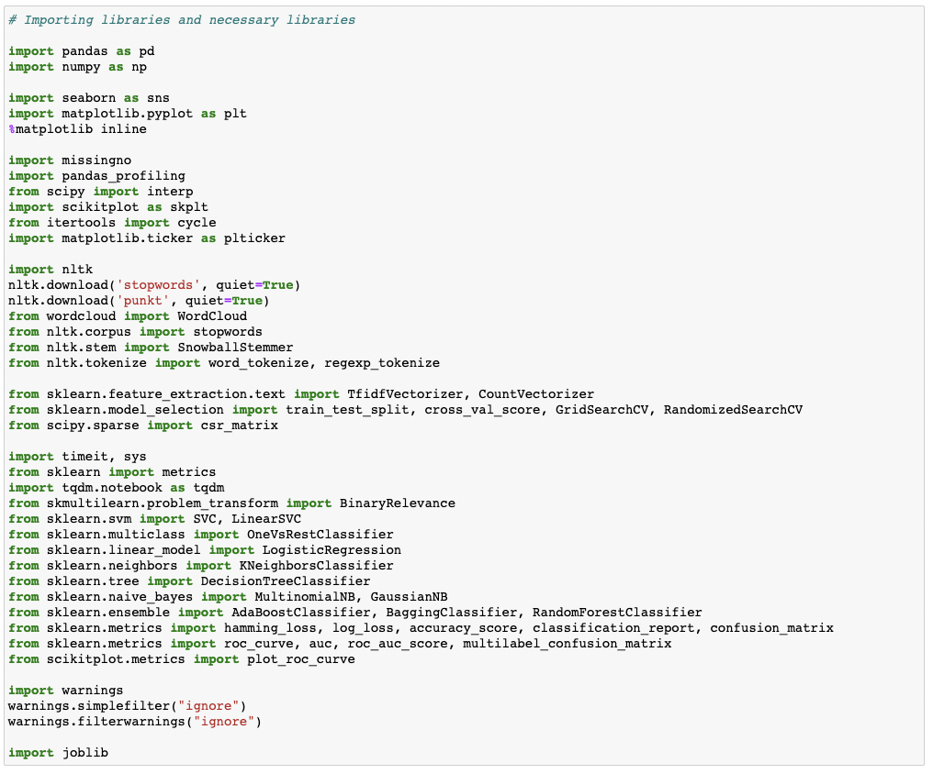

We were given two datasets to work with in this project: train and test CSV files. Using NLP and the train dataset, I will create a machine learning model. We'll generate predictions for our test dataset using this model.

Multiple classification machine learning models will be required.

All data pre-processing processes using NLP must be completed before model development. After experimenting with several classification models and hyper parameters, the optimal model will be chosen.

Will need to follow the entire data science life cycle, which includes procedures such as -

1. Data Cleaning

2. Exploratory Data Analysis

3. Data Pre-processing

4. Model Building

5. Model Evaluation

6. Selecting the best model

Finally, we used different machine learning techniques to compare the outcomes of suggested and baseline characteristics. The results of the comparison show that the recommended characteristics are important in detecting cyberbullying.

* **Data Sources and their formats**

The data set includes a training set with roughly 1,59,000 samples and a test set with nearly 1,53,000 samples. 'Id', 'Comments', 'Malignant', 'Highly malignant', 'Rude', 'Threat', 'Abuse', and 'Loathe' are all fields found in all data samples. The label might be 0 or 1, with 0 indicating a NO and 1 indicating a YES. There are a number of comments with several labels. Each comment has a unique ID, which is the first property.

The following items are included in the data set:

* Malignant: This is the Label column, which has values 0 and 1, indicating whether or not the comment is malignant.
* Highly Malignant: Comments that are exceedingly malignant and damaging are referred to be "particularly malignant."
* Rude: It refers to remarks that are obnoxious and rude.
* Threat: It includes indications of words that are threatening to someone.
* Abuse: It refers to statements that are abusive
* Loathe: Hateful and loathing comments are described as hateful and loathing comments.
* ID: It contains unique identifiers for each comment content.
* Comment text: This column comprises the extracted remarks from various social media networks
* **Data Pre-processing Done**

Before developing the classification model prediction, the following pre-processing pipeline must be completed:

1. Load the dataset

2. Remove any values that are null.

3. Remove the column id.

4. Lowercase the comment text and replace the 'n' with a single space.

5. Remove all other data from the comment text except text data (a-z).

6. Eliminate all stop words and punctuation marks.

7. Use the Snowball Stemmer to apply stemming.

8. Use TfidfVectorizer to convert text to vectors.

9. Load a model that has been stored or serialised.

10. Predict multi-class label values.

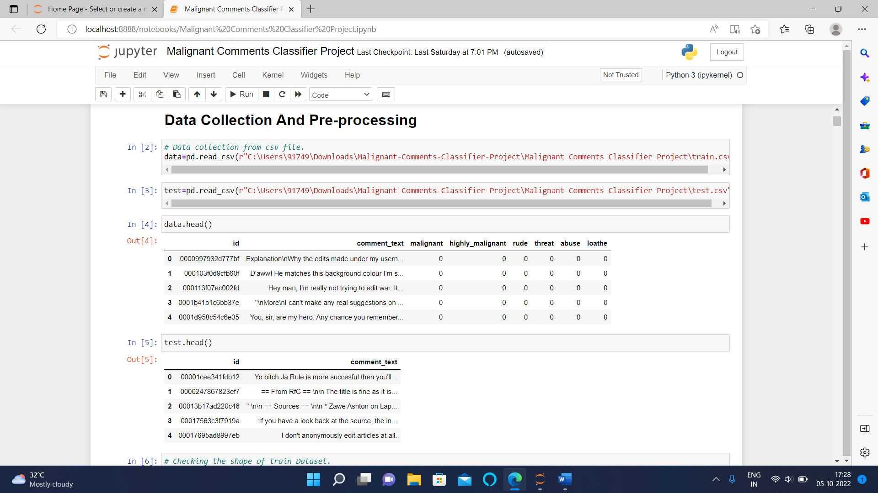

* **Data Inputs- Logic- Output Relationships**

A tag/word cloud is a unique visual representation of text data that is frequently used to display keyword information on websites or to view free-form text. It's a picture made from of words from a certain book or topic, with the size of each word indicating its frequency or importance

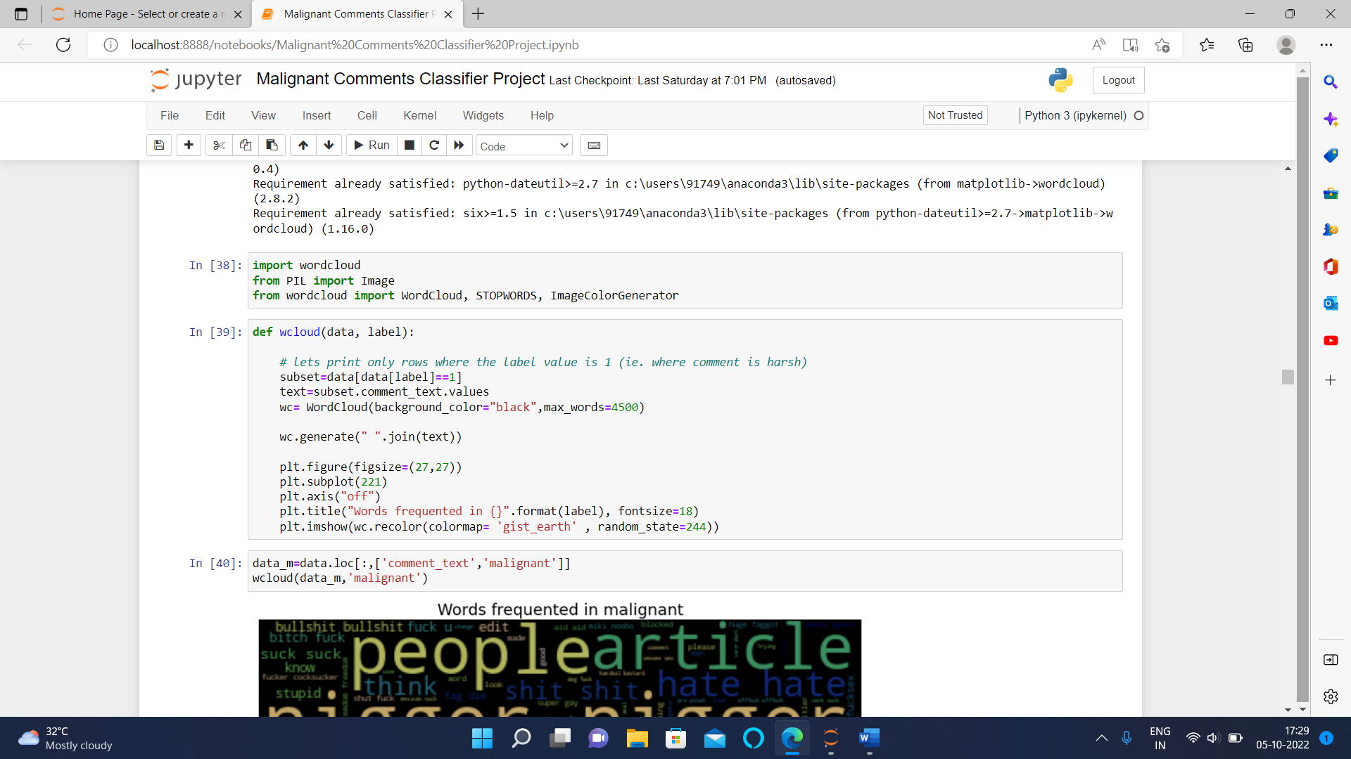









These are comments of various types, and with the assistance of a word cloud, we can determine if there is an abuse comment, what sort of words it includes, and how it compares to other comments.

* **State the set of assumptions (if any) related to the problem under consideration**

Cyberbullying is becoming more prevalent in countries all around the world. In essence, cyberbullying is quite similar to the sort of bullying that many youngsters have become accustomed to at school. The only difference is that it is conducted entirely online.

Cyberbullying is a severe problem that affects not only the young victims, but also their families, the bully, and anyone who witness cyberbullying. Cyberbullying, on the other hand, can have the greatest negative impact on the victim, since they may experience a variety of emotional disorders that influence their social and academic performance, as well as their general mental health.

* **Hardware and Software Requirements and Tools Used**

Here for this project, I used Jupyter notebook and tools used pandas and NumPy for mathematical operations, matplotlib and seaborn for various type of data visualizations.

**• Testing of Identified Approaches (Algorithms)**

LinearSVC

MultinomialNB

LogisticRegression

LGBMClassifier

SGDClassifier

* **Run and evaluate selected models**

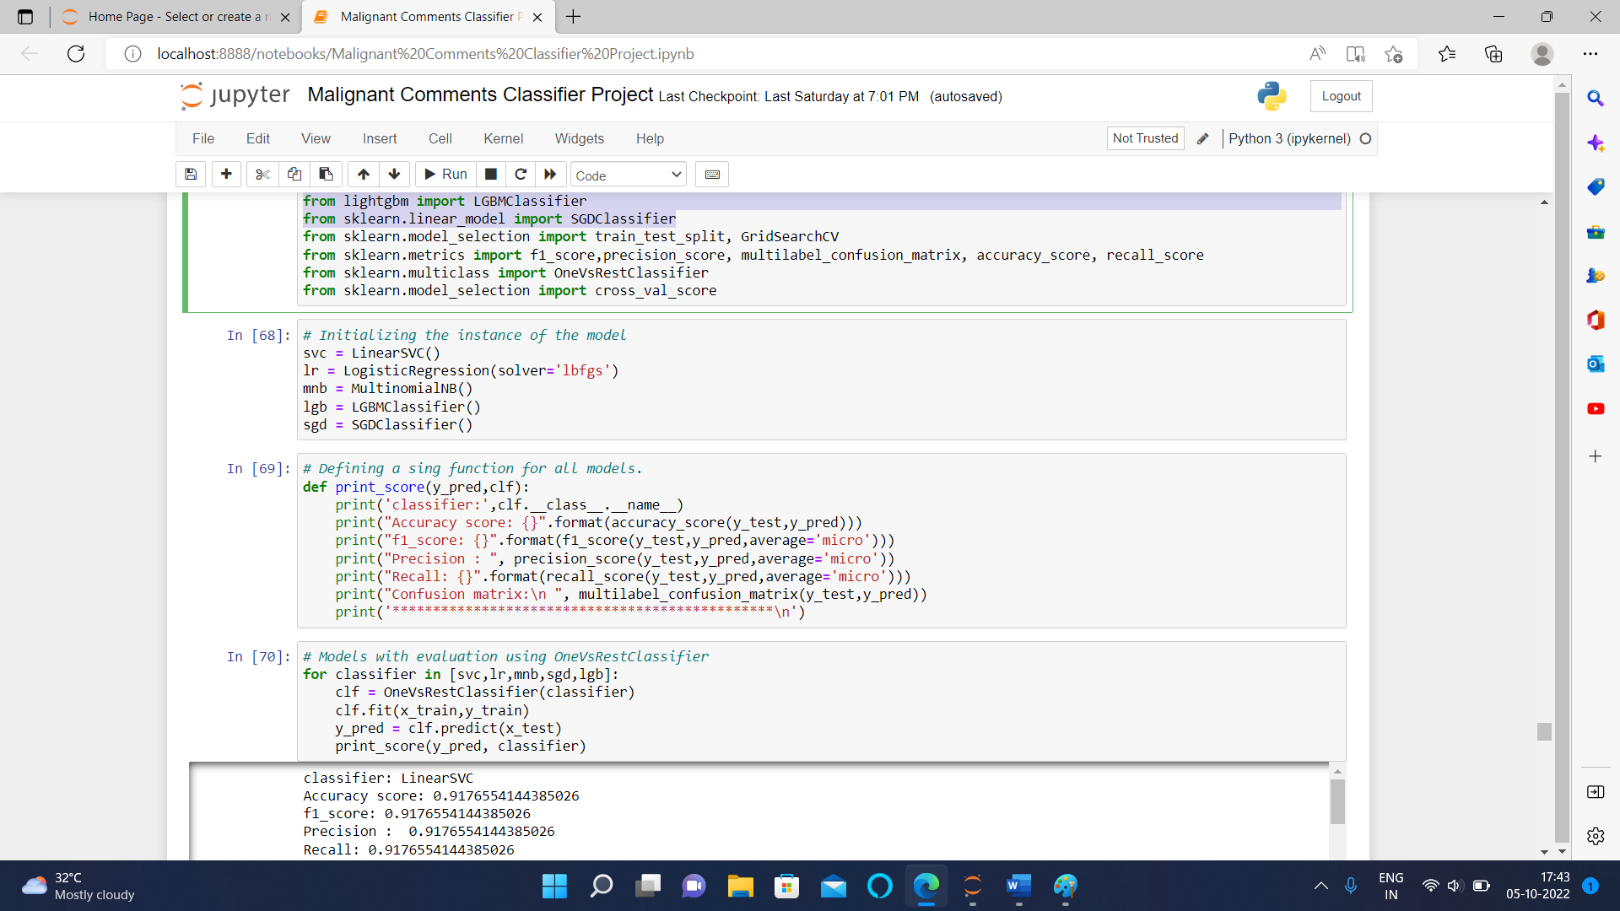

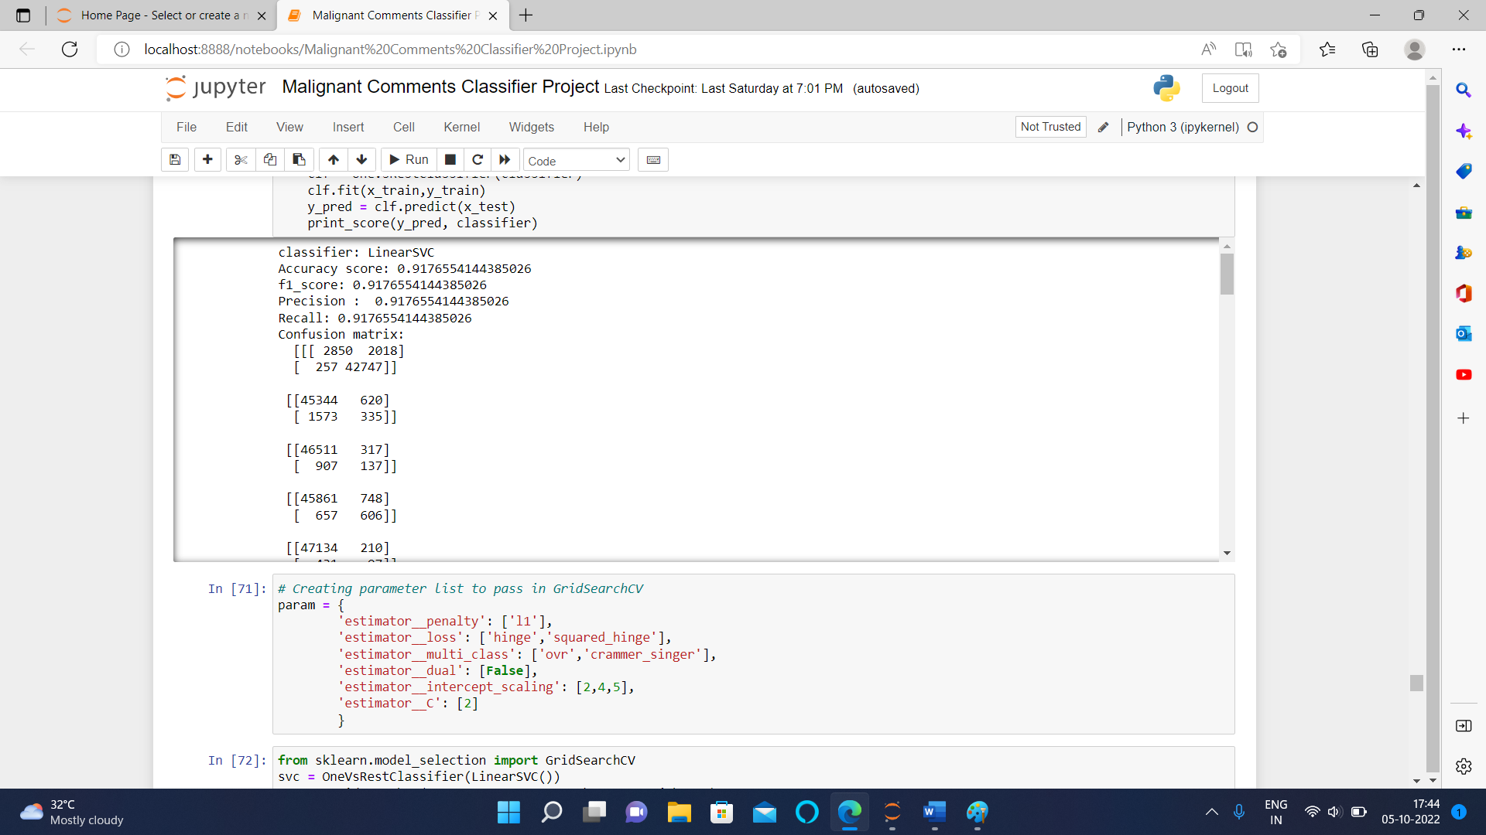

With an Accuracy Score of 91.35586783137106 percent and a Hamming Loss of 1.9977212305355107 percent, it is obvious that Linear Support Vector Classifier outperforms the other classification models. As a result, for the next step in the Hyperparameter tuning process, I'm going to employ a Linear Support Vector Classifier. I'll do my best to improve the accuracy score of our final categorization machine learning model using the hyperparameter tweaking method.

* **Visualizations**

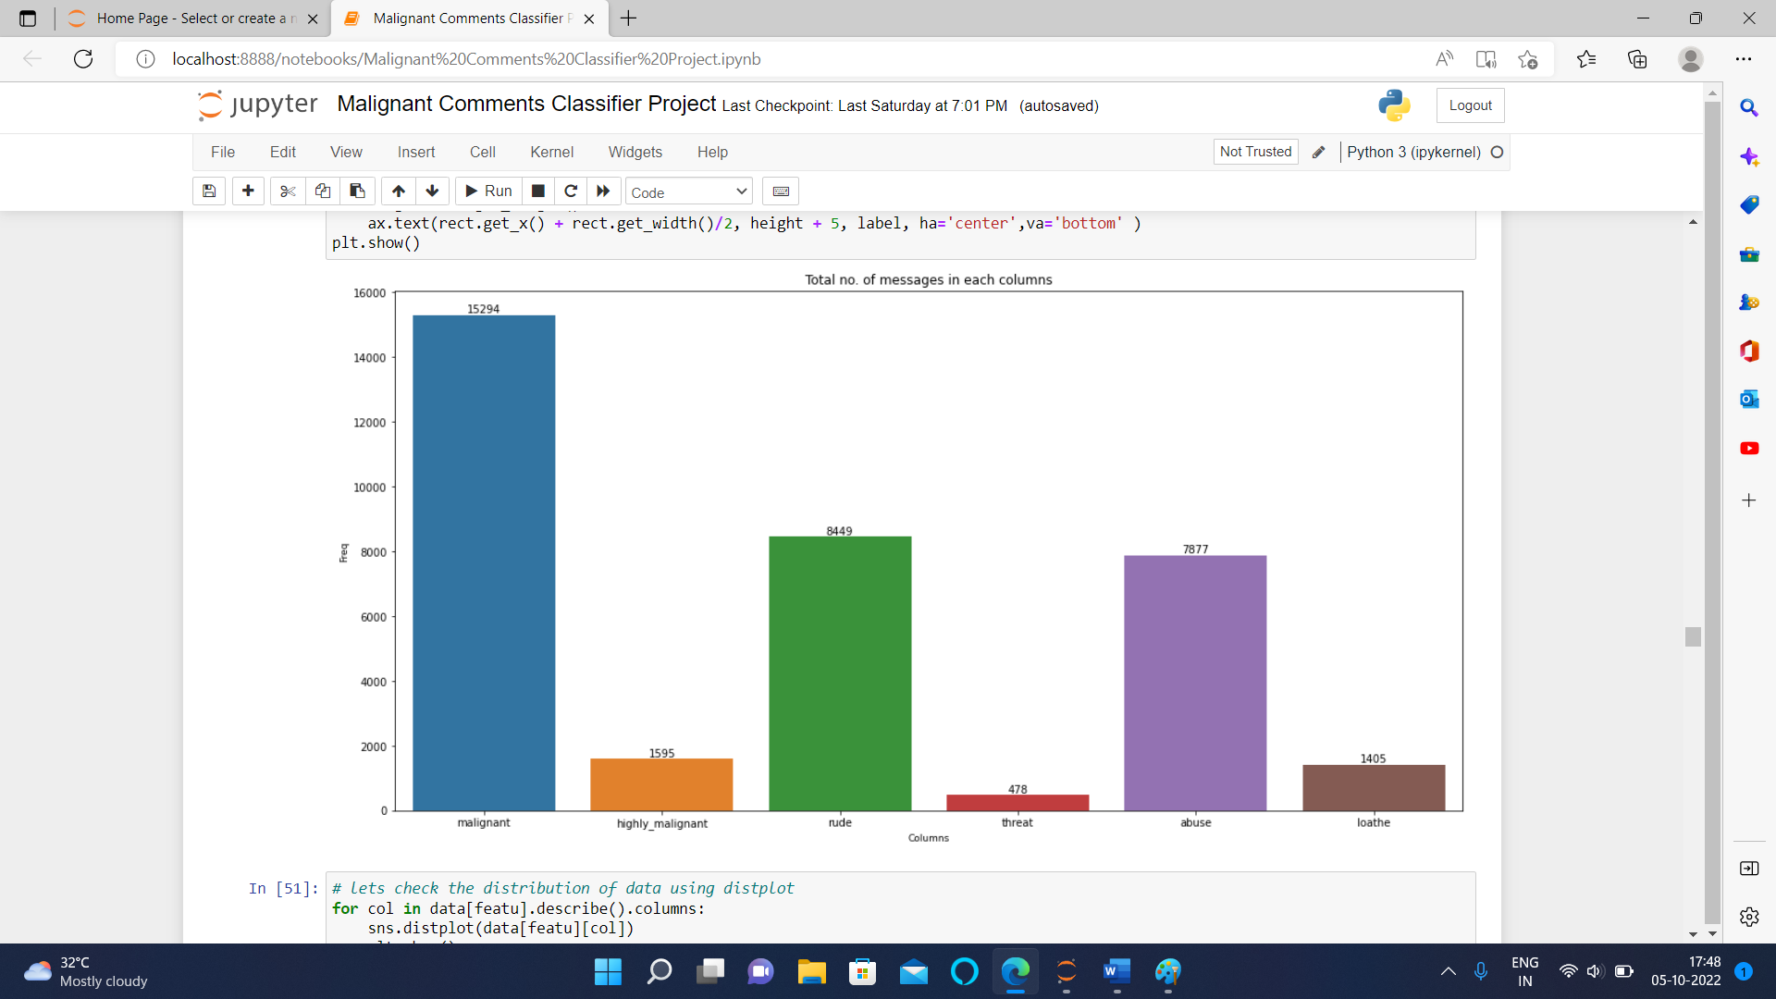

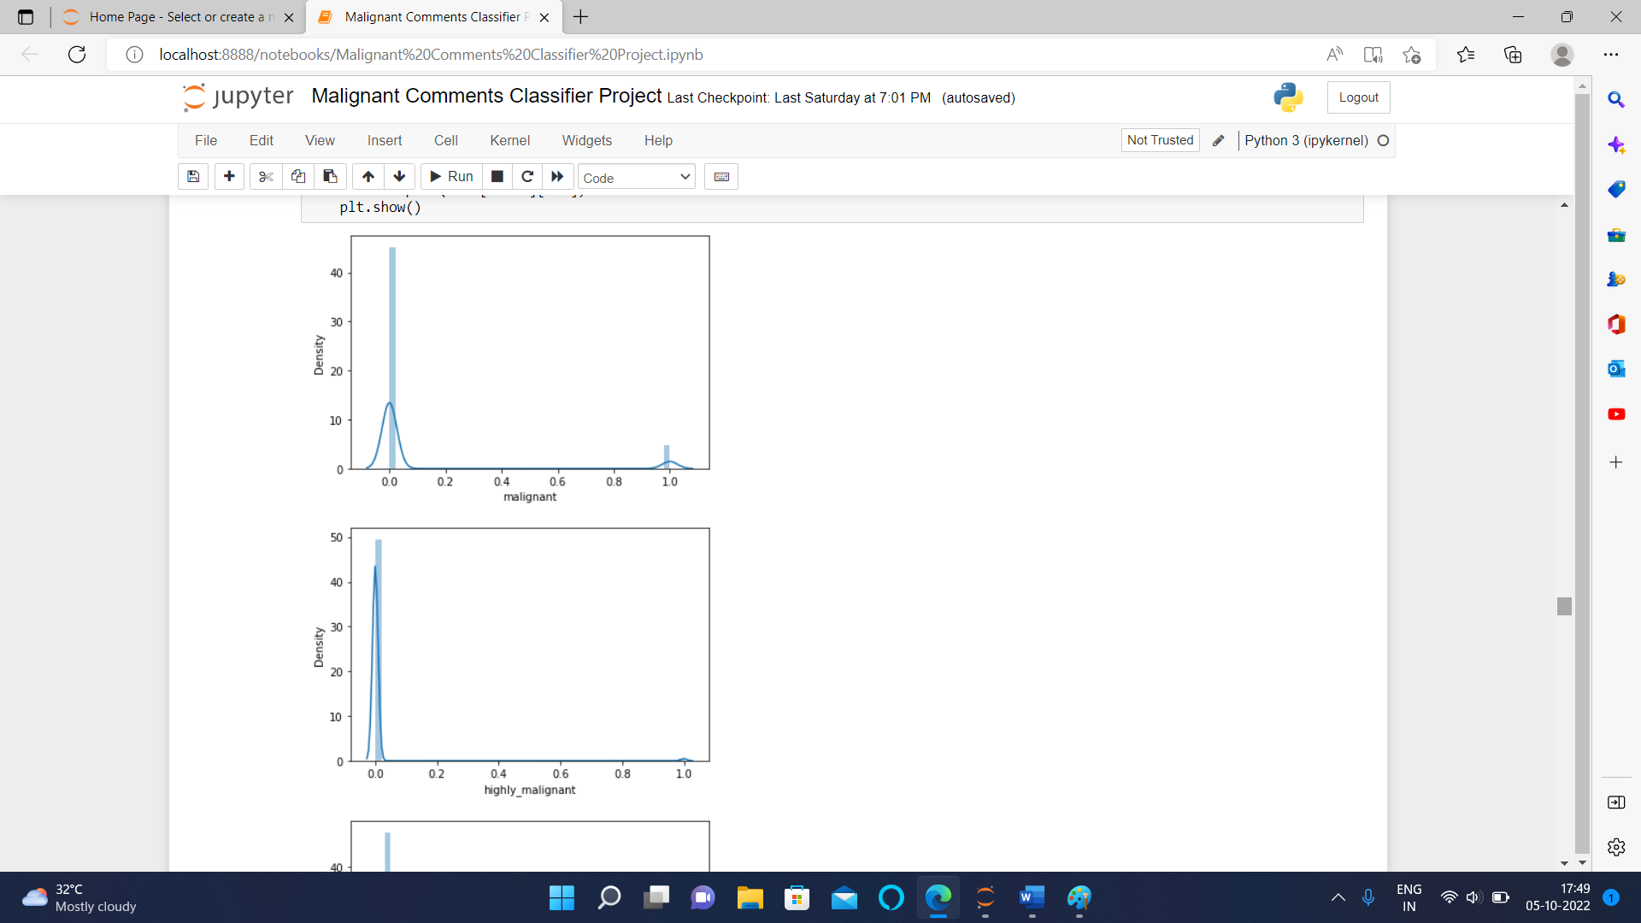

* Here in the first graph of malignant we can clearly observe that most of the messages are not malignant.
* In the second image we can clearly observe that there are very less highly malignant messages.
* Same in third picture there are few rude comments in the dataset.
* In 4th we can clearly see that there are very few cases/almost negligible of threat comments
* In 5th image we can clearly see that there are some messages with abusive language.
* While in the sixth image we can clearly see that there are very few cases of loathe messages.
* In 7th image we can see the no. of words in each row.
* In 8th image we can see the cleaned no. of remaining words in each row.
* **Key Metrics for success in solving problem under consideration**

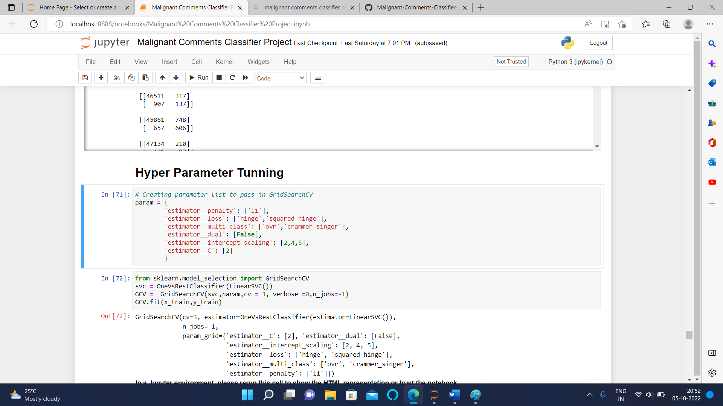

* **Interpretation of Results**

Starting with univariate analysis, it was discovered that the dataset is unbalanced, with more records for normal comments than for negative remarks (including malignant, very malignant, impolite, threat, abuse, and detest). Furthermore, using a distribution plot for comment length, it was discovered that after cleaning, the majority of comment length reduces from 0-1100 to 0-900. Moving on to the word cloud, it was discovered that malignant comments contain terms such as fuck, nigger, moron, hatred, suck, and so on. Words like ass, fuck, bitch, shit, die, suck, faggot, and others appear often in highly malignant remarks. Words like nigger, ass, fuck, suck, crap, bitch, and others are used in nasty statements. Words like death, must die, kill, murder, and others are used in threat statements. Words like stupid, nigger, obese, jew, bitch, and others are used in abusive comments. and despise remarks include phrases such as nigga, dumb, nigger, die, gay, cunt, and so on.